Directions: It’s been a while since covered a variety of topics from this course. This review worksheet covers some (not necessarily all) of the topics that we have learned. DO NOT take this review to be a copy of the final exam. Be sure to look over the Final Exam Study Guide and take heed of the other recommendations for preparing for the file. Remember that many of these problems are still Challenge Problems and therefore it is not expected that you might know how to answer each of these questions immediately.

- Compute each of the following limits.

- (where a and b are positive real numbers).

- . (Hint: Think about the form of the limit and what properties you might be able to take advantage of to get this limit into a more useful form)

- Let c be an arbitrary real number. Give examples of differentiable functions f and g satisfying:
and

- Give the definition of what it means for a function to be continuous at a. Give an example of a function which is continuous at all x. Give an example of a function which has a removeable discontinuity at . Give an example of a function which has a jump discontinuity at .

- Give the definition of . Use the definition to show that if the then .

- Consider the following three functions.
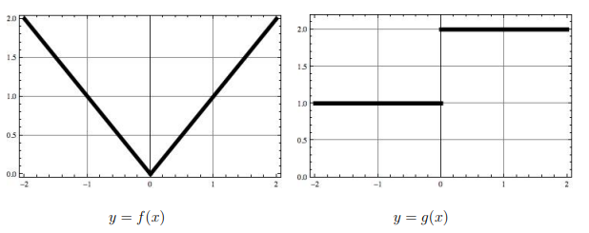

- Which of the functions are continuous?

- Which of the functions are differentiable?

- What is equal to?

- What is equal to?

- What is

- What is equal to?

- What is equal to?

- Consider the equation . Find .

- Find a formula for the function , given the information that f is a continuous function and that .

- Two vertical poles, one 4m high and the other 16m high, stand 15m apart on a flat field. You must support both poles by running rope from one spot on the ground to the top of each post. What spot on the ground should you choose, in order to use the smallest amount of rope? (First stop and think: what kind of problem is this? Related rates? Optimization? Differential/linear approximation? etc.)

- A Ferris wheel with a radius of 10m is rotating at a rate of one revolution every 2 minutes. How fast is a rider rising when his seat is 16m above the ground level? (First stop and think: what kind of problem is this? Related rates? Optimization? Differential/linear approximation? etc.)

- ACME Inc. has determined that the company profit determined by a function where x represents a special unique machine setting variable whose true meaning is only known by company higher ups. It is also known thathas an absolute maximum at its only critical point. Approximate the value of this critical point using Calculus.

- Give an example where and are increasing at but is decreasing at for some value of a.

- Consider the function . Answer the following question without the use of a calculator.
- How does f behave as ?

- Where are the critical points of f ? Where is f increasing, decreasing?

- Determine the inflection points of f and where f is concave up and concave down.

- Which of the following graphs is likely a graph of f ?

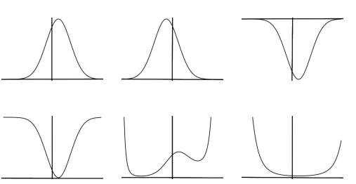

- Let f be a function whose second derivative is continuous for all real numbers. Show that if is the minimum for f and the maximum for f then for some c between 1 and 3. Here is the graph of a sample function with these properties.

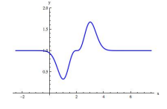

- Consider the integral .
- Sketch the net area represented by the integral and compute it using geometry.

- Compute the integral using the Fundamental Theorem of Calculus.

- Compute the integral by using the definition of definite integral.

- Calculate each of the following.

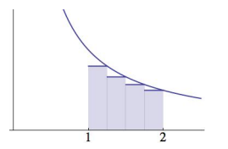
- The following is a graph of with some shaded rectangles.
- Explain how the diagram leads to the inequality .

- Explain why .

- Let where h and b represent arbitrary positive real numbers.

- Sketch the graph of being sure to label the x-intercepts and y-intercepts.

- Determine the area of the finite region bounded by the graph of and the x-axis. Fully simplify your answer.

- Suppose that , is continuous, and , what is the value of ?

- A point is moving along the x-axis with acceleration at time t. If its initial velocity is 27, how far does the particle move from time to time ?

- A patient is experience blood loss at a rate of pints per minute at time t (as t increases, the blood loss slows due to decreased pressure). Approximately how long before the patient loses 3 pints of blood after ?

- During a race, the velocities of two cars were plotted, and . After the first hour, car A was ahead of car B but car B finished the race in 2 hours, which was 15 minutes (0.25 hours) ahead of car A. From this information we can say… (fill in in the space)

